F O R S A L E — U S E D C O N C R E T E B A T C H I N G P L A N T
McCRORY ENGINEERING
Complete Modular Concrete Batching Plant
Turnkey Package · Only ~4,500 Operating Hours · Full Service History
£100,000 + VAT
Exceptional value · Available for immediate inspection and removal

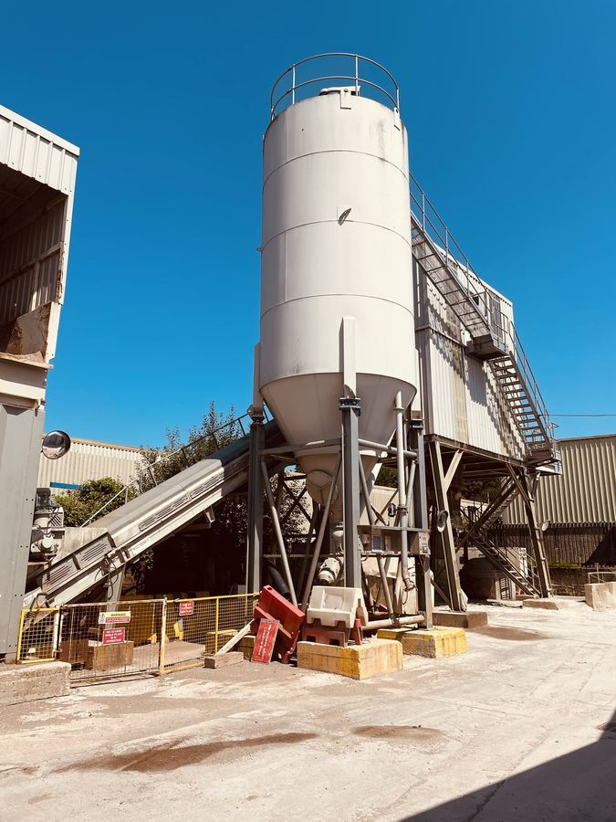
The plant as currently installed — Cinderford, Gloucestershire
OVERVIEW
A complete, modular concrete batching plant by McCrory Engineering, offered as a turnkey package ready for relocation and operation. Installed new in 2017 and used lightly — averaging around two hours per working day — the plant has accumulated only approximately 4,500 operating hours, a fraction of what a plant of this age would typically see. It has been professionally serviced every six months by DNC Engineering from new, and is offered fully operational and exceptionally well maintained, complete with its generator, tanks, compressor and full 964-page maintenance manual (serial no. MC170420.3).
AT A GLANCE
Manufacturer | McCrory Engineering
Plant type | Modular concrete batching plant — turnkey
Mixer | Teka THZ 1500 pan mixer — 1.0 m³ batch output (37 kW)
Year installed | 2017
Operating hours | Approximately 4,500 (avg. ~2 hrs per working day)
Control system | Practicon C-PAK Micro computer control
Cement storage | 60 tonne silo with load cells, aeration & filtration
Aggregate storage | 2 × 30 tonne bins with moisture probe & vibrators
Service history | 6-monthly by DNC Engineering from new (18+ services)
Location | Cinderford, Gloucestershire — viewings by appointment
Price | £100,000 + VAT

PHOTOGRAPHS
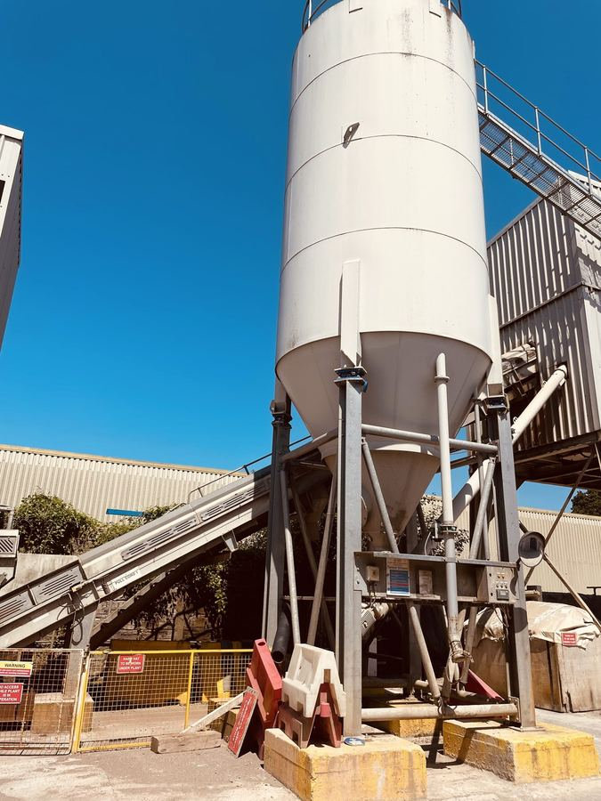  Mixing tower & 60-tonne cement silo | 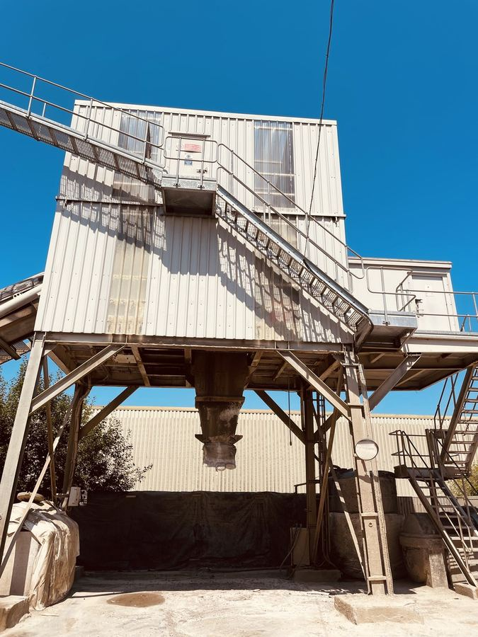  Mixing tower, cladding & access platforms
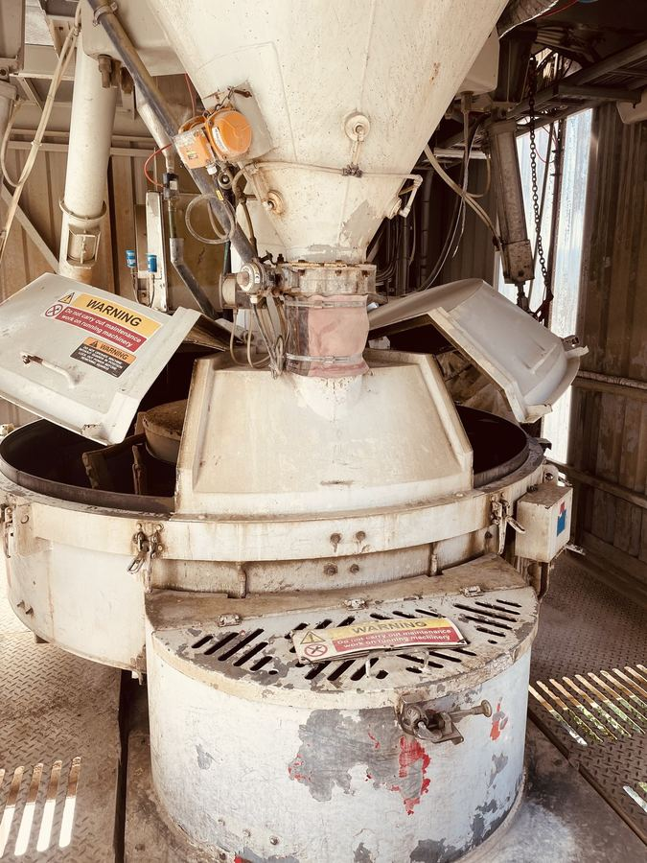  Teka THZ 1500 pan mixer | 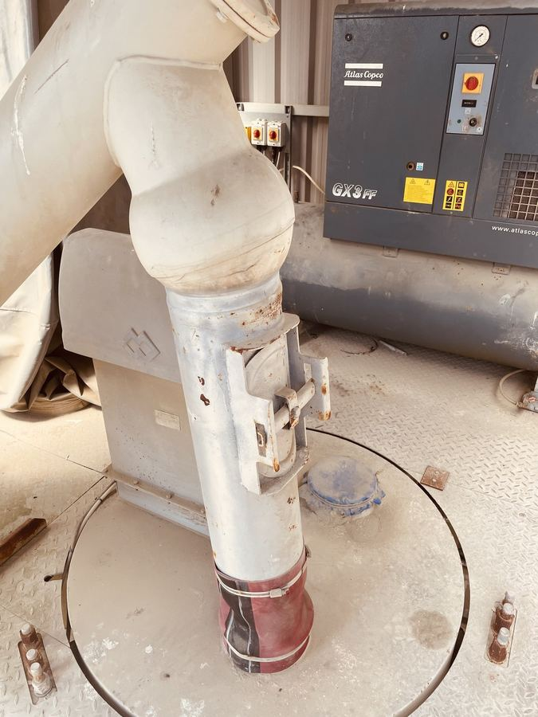  WAM screw conveyor & cement weigh hopper
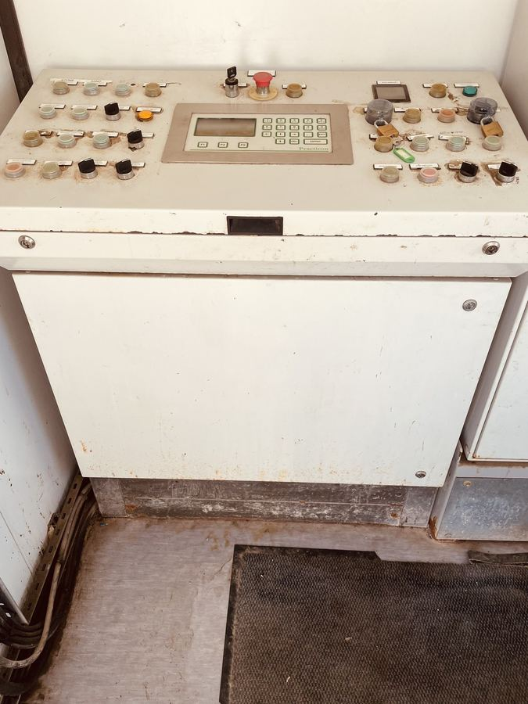  Practicon C-PAK Micro control system & control room | 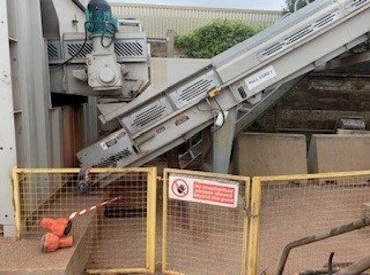  13 m inclined batch conveyor with catwalk
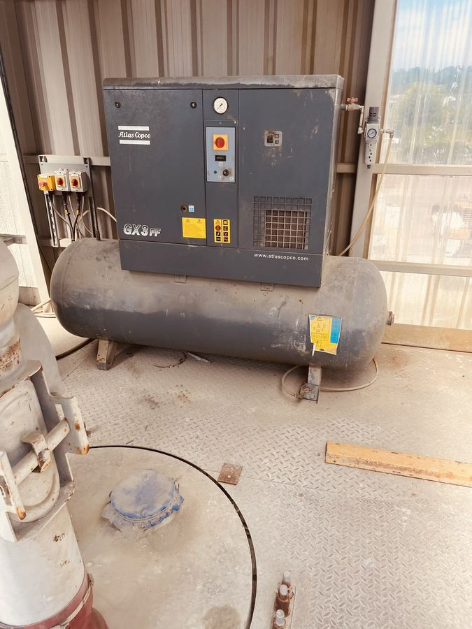  Atlas Copco GX3 compressor with integrated dryer | 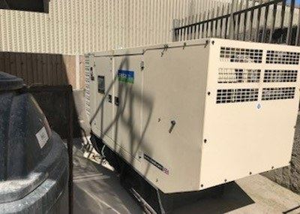  Generator unit — independent power supply

KEY EQUIPMENT INCLUDED
The plant fully matches the detailed manufacturer specification. Main components include:
Aggregate section
• 2 × 30,000 kg storage bins with pneumatic gates and vibrators
• Aggregate weigh hopper plus 11 m drag-out conveyor
• 13 m inclined batch conveyor with catwalk and dust covers
Mixing tower
• Teka THZ 1500 pan mixer (37 kW) — 1.0 m³ batch output
• Cement weigh hopper (1,000 kg)
• 2,250 litre water tank with Grundfos high-pressure wash-down system
• Full cladding, stairways and platforms
Cement storage & transfer
• 60 tonne silo with load cells, aeration pads, filter and safety systems
• WAM 219 mm screw conveyor (15 kW)
Ancillary systems
• Atlas Copco GX3 compressor with integrated dryer
• Practicon C-PAK Micro computer control system
• Full electrical control panel and pre-wiring
• Admix dosing system (Line Aliva)
• Generator unit for independent power supply
• 6,000 litre water tank, 5,000 litre diesel tank, 500 litre additive tank
• Complete lighting and safety equipment

WHY THE LOW HOURS MATTER
• Industry standard: Most 9-year-old plants have 15,000–20,000+ operating hours.
• This plant: only ~4,500 hours — approximately 30% of typical usage.
• Remaining life: equivalent condition to a heavily-used 3-year-old plant.
• Component wear: minimal wear on motors, bearings, belts and hydraulics.
WHY BUY THIS PLANT
✓ Low operating hours — only ~4,500 vs. an industry-typical 15,000+
✓ Professional 6-monthly service history by DNC Engineering from new
✓ Complete turnkey package — generator, compressor and all tanks included
✓ Minimal component wear — condition of a 3-year-old heavily-used plant
✓ McCrory Engineering build quality — a reputable manufacturer
✓ Full documentation — 964-page maintenance manual plus service records
✓ Immediate availability — ready for inspection and removal
COMMERCIAL TERMS
Price: £100,000 + VAT

Payment terms
• 40% deposit with order
• 50% prior to dismantling / upon inspection
• 10% on successful removal (pay before leaving site)
Payment to be made to Rackham Housefloors Ltd.
Exclusions
• Dismantling, transport and re-erection (can be arranged separately)
• New foundations at the buyer's site
• Mains electrical and water supply connections
Warranty
Plant offered as seen with full service history. Any transferable manufacturer warranties on major items will pass to the buyer. Support with re-commissioning available if required.
CONTACT & VIEWINGS
Roger Varley
Technical Director
Mobile: 01924455876
Cinderford, Gloucestershire · Site visits welcome by appointment

