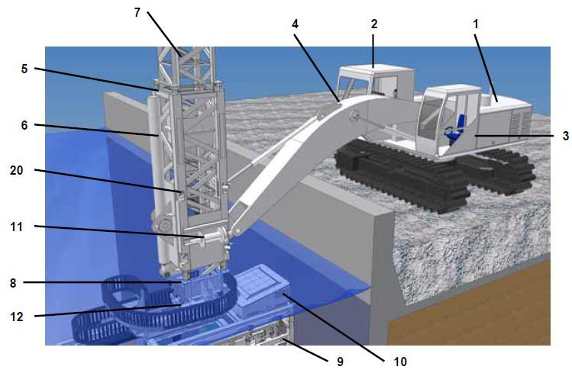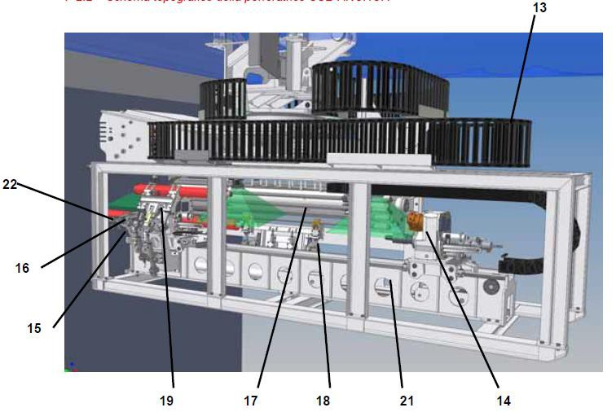

10 th of November 2021

Sub-Anchor U-055 equipment sum up

2. Drilling control cabin

5. Guide trellis

6. Truss movement piston

7. Upper truss

8. Lower truss

9. Drilling frame

10. Box for distributors and logic

11. Winch

12. Turntable

13. Pipe holder chain

14. Rotation head

15. Unscrewer

16. Morse

17. Drum holder rod

18. Hand grip rods

19. Core drill manipulator

20. Truss blocking block

21. Mast beam

