Windows 10 Pro Default Image – Build & Capture

Prerequisites
Follow the steps in the document Windows 10 Imaging MDT Build Structure Setup to create a Virtual Machine that is used to deploy the base OS.
Note: The default image uses administrator profile as the basis of customization and capture.

Snapshots
Snapshotting a VM before capturing an image is a very important step. It is important to take a snapshot of the VM after it has been shut down, and before you double-click the Resume Task Sequence icon on the desktop of the “Administrator” profile.

OS Configuration
After the base OS is deployed, the desktop will resemble the following:
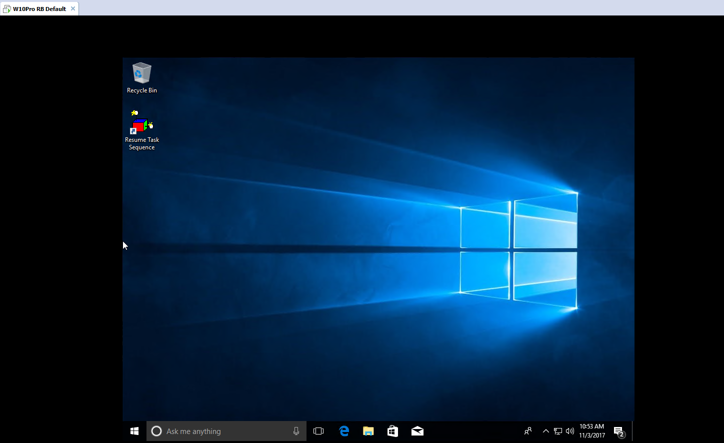

Important: DO NOT delete the Resume Task Sequence icon on the desktop.

Configure Local User Accounts
The following table describes the local user accounts and how they should be configured:

- Click Start, type compmgmt.msc, and then press ENTER.
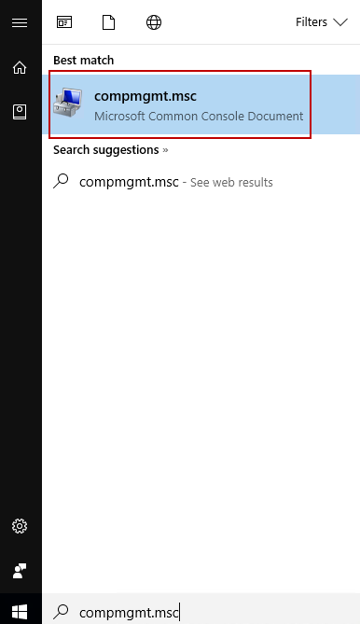
- In Computer Management, expand Local Users and Computers. Right-click Users and then click New User.
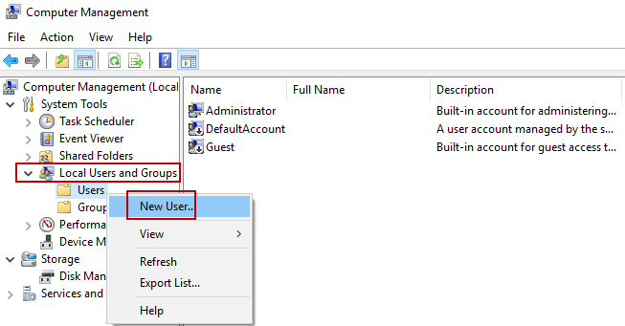
- The following table describes the local user accounts and how they should be configured.
Full Name | User ID | Groups | Purpose
Administrator | Administrator | Administrators | DISABLED AFTER image deployment.
rservice | rservice | Administrators | Used by support centre and operations
Follow these steps to create the accounts and add them to the local groups:
- Type the information from the table to the corresponding fields in the New User dialog box.
- Type the password in the Password and Confirm Password boxes. Note: Contact the IT Operations Analyst team to obtain passwords.
- Click to select the User cannot change password and Password never expires check boxes.
- Click Create.
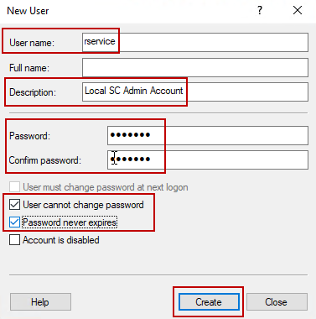
- Double-click the account you just created, and then on the Member of tab, click Add.
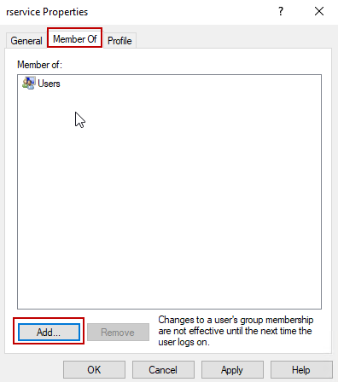
- In Select Groups, in the Enter the object names to select area, type Administrators and then click Check Names. The group name is underlined if the correct value was entered.
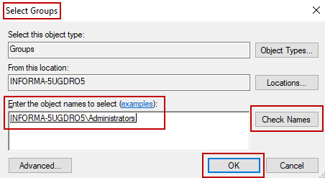
- Click OK.
- Double-click the account again, and then on the Member of tab, click Users, and then click Remove.
- Repeat steps a - i to setup other accounts, as needed.
- Click Start, type Group Policy, and then click Edit group policy.
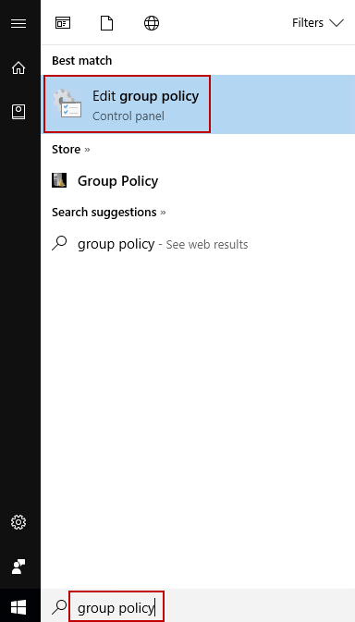
- In Local Group Policy Editor, set the following group policies
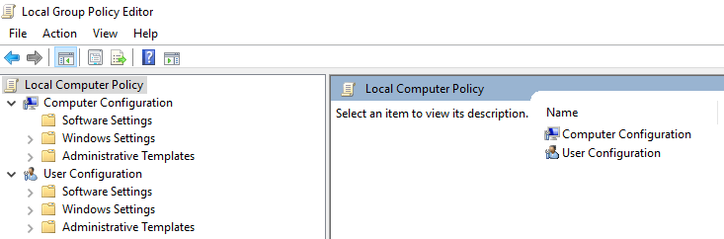
  - Expand Computer Configuration > Administrative Templates > Windows Components > Store, and then configure the following policies:
    - “Turn off the store application” set “Enabled”.
    - “Turn off Automatic Download and Install of updates” set “Enabled”.
  - Expand User Configuration > Administrative Templates > Windows Components > Internet Explorer > Advanced settings >Browsing, and then configure the following policies:
    - “Hide the button that opens Microsoft Edge” set “Enabled”.
- On the hqppwmdt01 server, go to C:\Setup\Scripts\. Copy the script Invoke-RemoveBuiltinApps.ps1 and paste it to the desktop of the computer that you are configuring.
- Start PowerShell and browse to the administrator’s profile desktop folder.
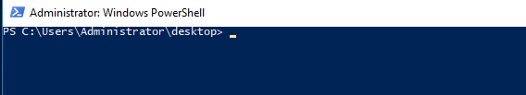
- Type the command Set-ExecutionPolicy UnRestricted and then press ENTER.
- When prompted to continue, type A to change the execution policy.
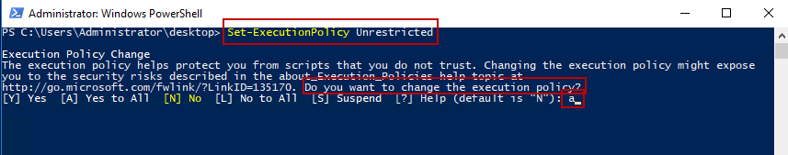
- Type the name of the script file and then press ENTER.
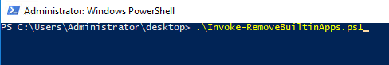
The following messages appear.
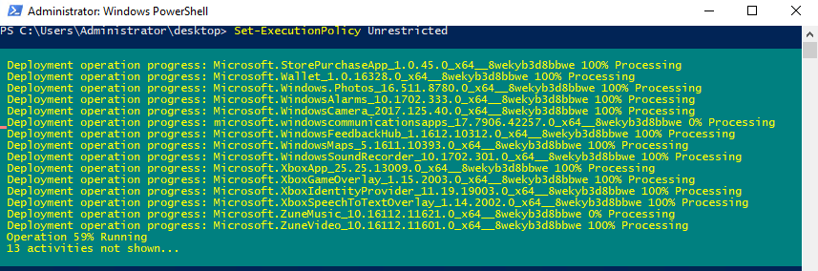
If the command completes without error, PowerShell will return to the prompt.
When successfully completed, delete the script from the desktop.
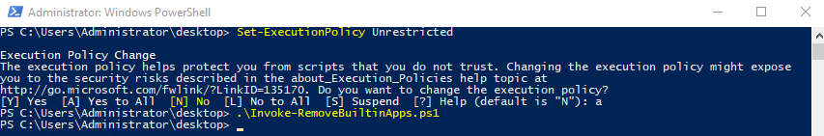
- Click Start and unpin all the apps in the right-hand side of the menu. Also, unpin all shortcuts from taskbar except IE and File Explorer. The following screenshot shows what Start menu and taskbar should look like when you are finished.
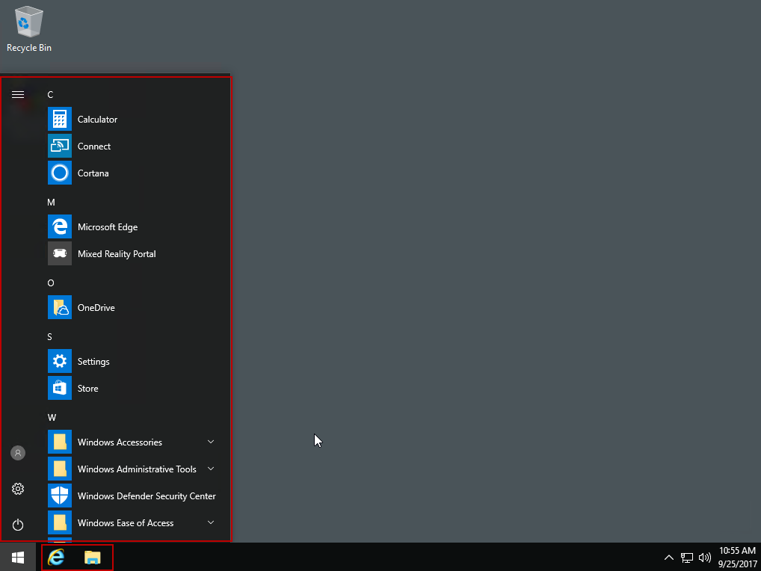
- Start File Explorer and then on the File menu, select Change folder and search options. Set the following options:
  - On the General tab, in the Open File Explorer to list, select This PC.
  - On the View tab, click to select the Show status bar check box.
  - Click Apply to Folders, and then click Apply.
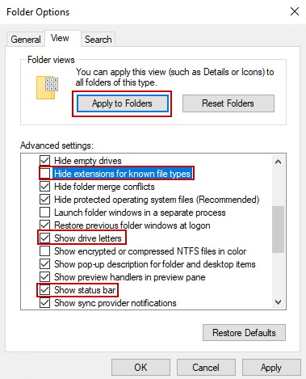
- Click Start, type user, and then select Change User Account Control Settings.
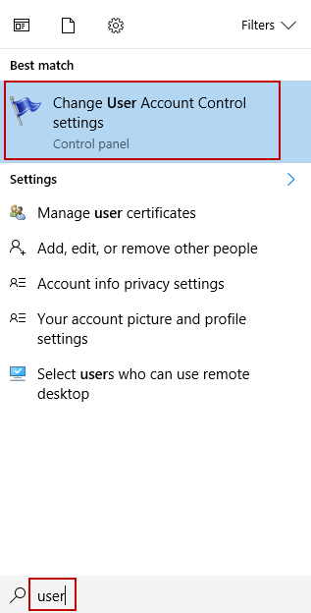
- In User Account Control Settings, move the slider level down to Never notify, and then click OK.
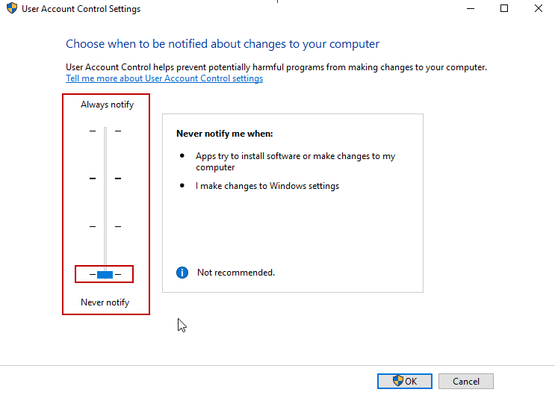
- Click Start, and then click the gear icon to open Settings.
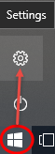
- In Windows Settings, click Time & Language.
- On the Date & time page, toggle On the Set time zone automatically option.
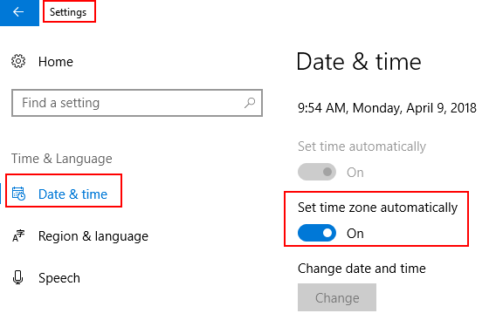
- Click Home to return to the Windows Settings page, and then click Devices.
- Select Printers & scanners and clear the Let Windows manage on my default printer check box and then close Settings.
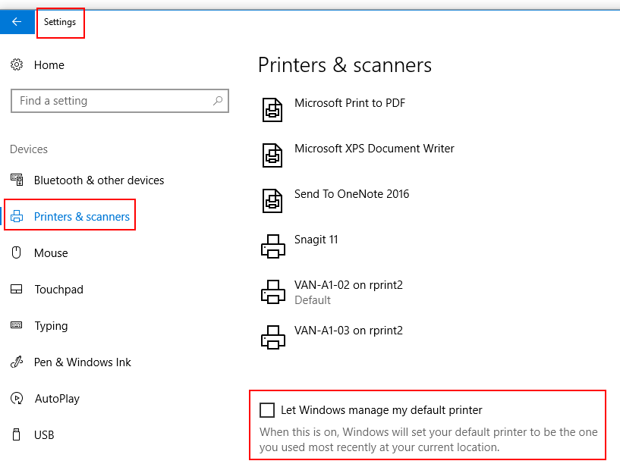

Customize the Start Menu and set File Associations
The Start menu and File associations may need to be modified depending on what the image will be used for. There are no default customizations. For information about how to customize the Start Menu and set File Associations, go to the following System Center Dudes blog post:
https://www.systemcenterdudes.com/sccm-windows-10-customization/

Install Software under the Administrator profile
The following software must be installed while you are signed on as the Administrator.
- Install SAP Crystal Reports runtime engine from the following location:
file:///\\vanstore1\software\Applications\SAP Crystal Reports
- Install Auction Client from the following location: \\vanstore1\Software\Applications\Auction Client .
- Install Postgres ODBC drivers from the following location:
\\vanstore1\software\Applications\PostGres\psqlodbc_09_06_0500
- Install SQL native client (sqlncli11.msi) from the following location:
\\vanstore1\software\Applications\Salesite\Prerequisites
- Install Flash & Shockwave by retrieving offline installers from online:
http://get.adobe.com/flashplayer/otherversions/
- Install Cisco Anyconnect VPN Client from the following location:
\\vanstore1\Software\Applications\VPN Clients\Cisco AnyConnect\AnyConnect 4.0.00057\RBAVPN-R-WIN-4000057
- Install Avaya One-X Communication from the following location:
\\vanstore1\Software\Applications\Avaya\One-X Communicator Release 6.2.2.07
- Install Chrome from the following location: https://www.google.com/intl/en/chrome/browser/desktop/index.html?standalone=1
- Install FireFox from the following location:
https://www.mozilla.org/en-US/firefox/all/
- Install Java from following location:
file:///\\vanstore1\software\Applications\Java\Java 8 64bit

Disable Java Update
Java must not update automatically because some Ritchie Bros. software will not work correctly with a different Java version. To disable Java Update, follow these steps:
- Click Start, type regedit and then press ENTER. Registry Editor opens.
- Expand the following key: Computer\HKEY_LOCAL_MACHINE\SOFTWARE\WOW6432Node\JavaSoft\Java Update\Policy.
- Double-click Enable JavaUpdate.
- In the Value Data box, change the value to 0, and then click OK.
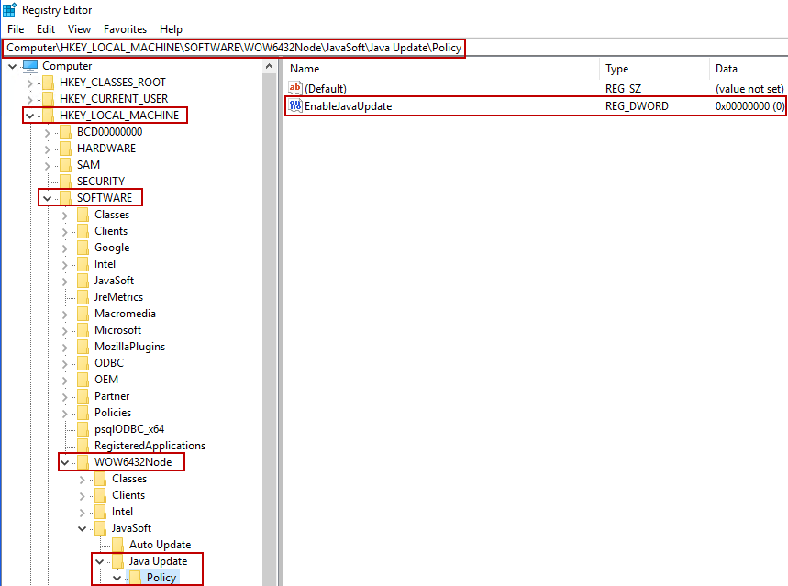
- Close Registry Editor.

Set Photo Viewer as default
By default, Windows 10 uses the new Photos app as the image viewer. To information about how to change this to Windows Photo Viewer, go to the following How-To Geek article:
https://www.howtogeek.com/225844/how-to-make-windows-photo-viewer-your-default-image-viewer-on-windows-10/

Windows 10 Updates
To install the latest Windows 10 cumulative updates, search the Microsoft Software Catalog for the updates that are missing.
For example, if you are using build 1703, search for the latest cumulative update to install for this build. To access the Microsoft Software Catalog, go to https://www.catalog.update.microsoft.com/Search.aspx?q=1703%20cumulative

Cleanmgr.exe
Run Disk Cleanup before you capture the image. Disk Cleanup locates temporary files and unneeded windows updates. Delete these files to create more storage space.
- Click Start, type clean, and then click Disk Cleanup.
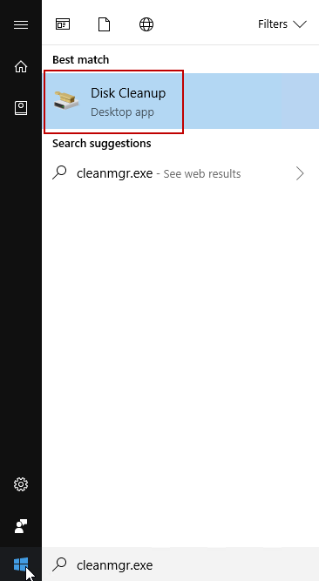
- In the Files to delete area and click to select the check box beside the files to be deleted, and then click OK.
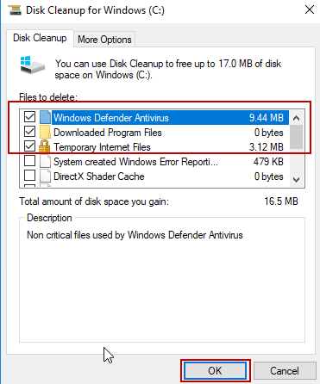
- After the cleanup is finished, restart the VM.

Capture the Image
- Shutdown the VM computer.
- Take a Snapshot of the VM. Make sure you put relevant into in the Snapshot name. You may also add information to the description field to highlight what changes this snapshot includes.
- Start the VM.
- On the desktop, double-click Resume Task Sequence. The capture process starts.
- For information about where the captured .wim file is stored, see the SharePoint Build and Configure Knowledge Base article Image Build and Capture using MDT Lite Touch - Windows 10.docx.

