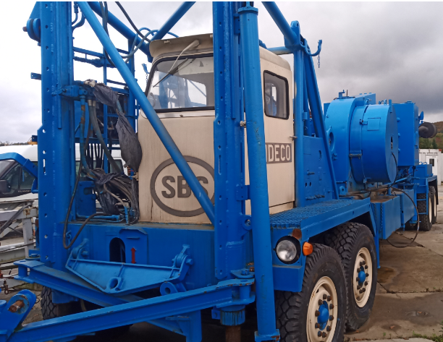
IDECO SBS

Manufactured in 1966 / Recertified in 1989/2001
Serial number 163
Manufactured in the USA

MAST
Type KM 90/95 – 180 GH
Clear Height 95 ft (29 m)
Max. Hook Load Capacity 250,000 lbs (112 t)

SUBSTRUCTURE
Type IDECO SBS
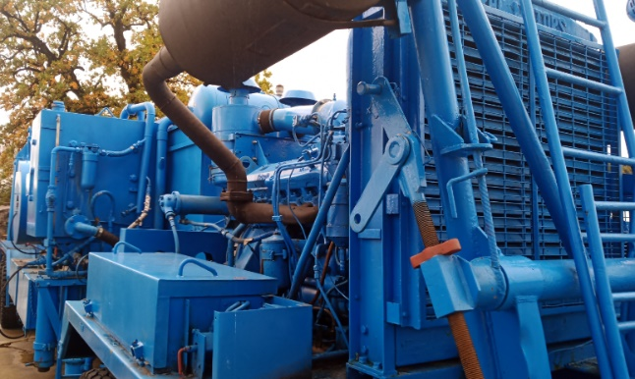
Setback Capacity 220,000 lbs (100 t)
Rotary Capacity 250,000 lbs (112 t)
Height underneath Rotary Beams 9 ft (2.9 m)

DRAWWORKS
Type IDECO H35ED
Max. Line Pull, 2nd Layer 30,000 lbs (13,5 t)
Drilling Line 1 in
Rated Input Power 350 HP
Auxiliary Brake Hydromat
Drive Detroit Diesel 12V71-N

RIG POWER SYSTEM
Drive Diesel
Type of Engines 1 x Detroit Diesel 12V71-N (drawwarks)
Nominal Rated Power 396 HP

MUD PUMPS
Type (Triplex Pumps) EMSCO F500
Number 2

ROTARY TABLE
Type SK 175

BLOCK
Type Block Mc Kissick 150
Capacity 150 t

MUD TANK SYSTEM
Number 2
Capacity 80 m³
LP Mixing System,
Mud Agitators,
Degasser

SOLIDS CONTROL EQUIPMENT
Type 2 x SWACO Mongoose
Shale Shaker
Type 1 x 10" Desander
Type 10 x 4" Desilter

