Serial No. SP090101

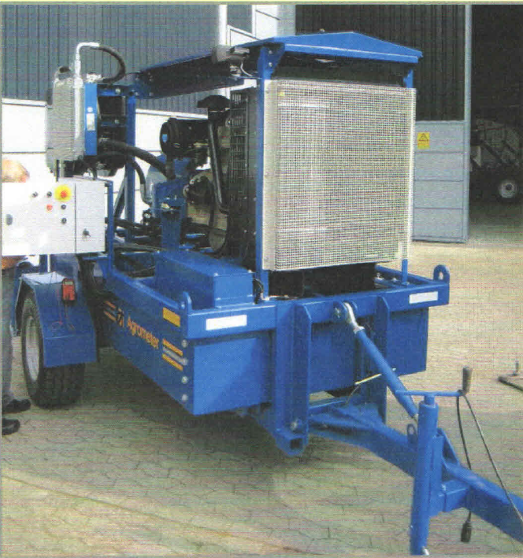

**AGM Mixer Pump Unit**

Model Pump unit

Type AGM Mixer

Date 2009

Working hours 9673

**INFORMATIONS ENGINE SPECIFICATIONS**

Weight with out fuel: app 3000kg Engine: John Deere Generator Diesel

Weight with fuel: app 4500kg Type: 6068HF258

Fuel tank: 1500 ltr Performance: 189 kW at 1800 rpm

Hydraulic tank: 200 ltr Type pressure: 4.75 bar

Hydraulic type: Castrol Hyspin AWS 46 Transport speed: Max. 30 km/h